Mysql oprator installation steps:

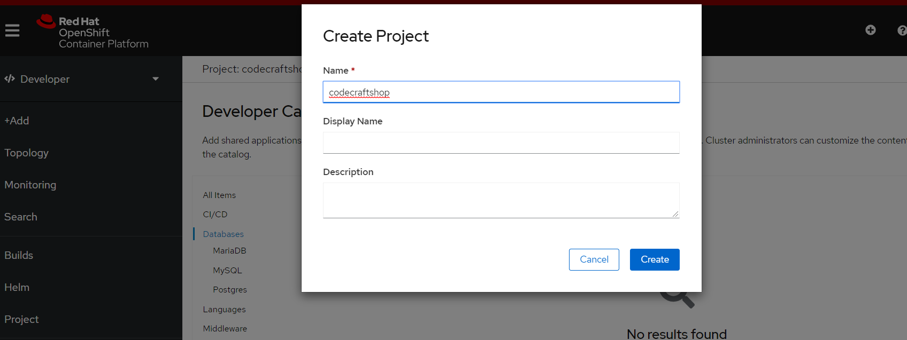

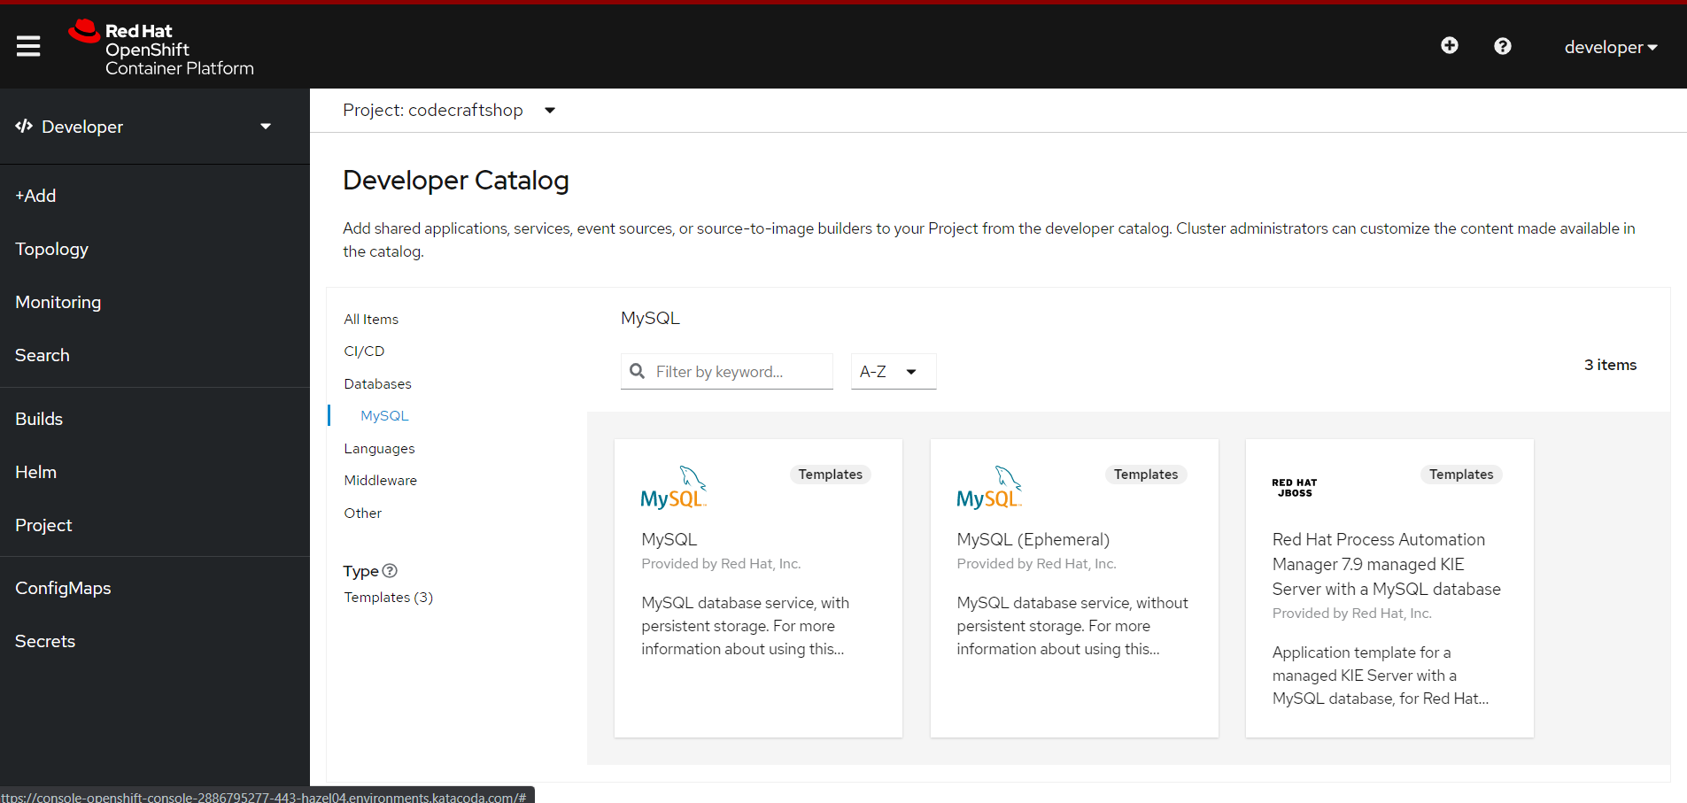

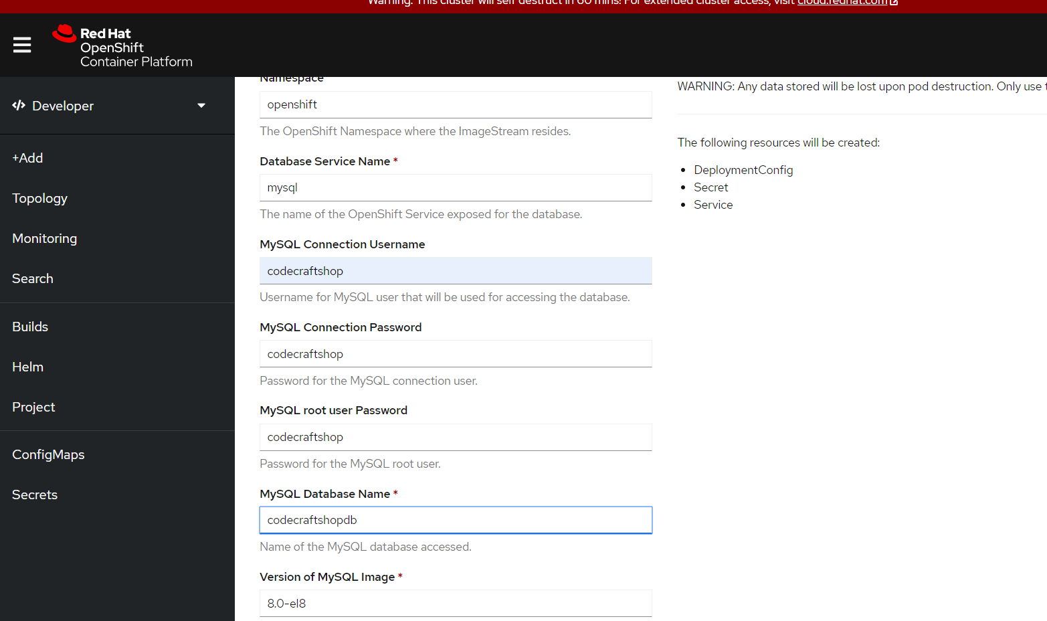

**To connect application using ClusterIP, need to expose as mentioned below:**

oc expose service/mysql -n <namespace>

**Connection string:**

spring.datasource.url = jdbc:mysql://<clusterip>:3306/dbname?useSSL=false

**or:**

jdbc:mysql://mysql.mysql-example.svc.cluster.local:3306/test

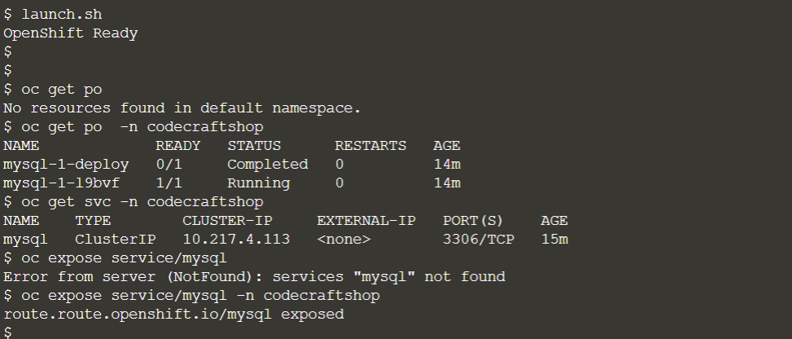

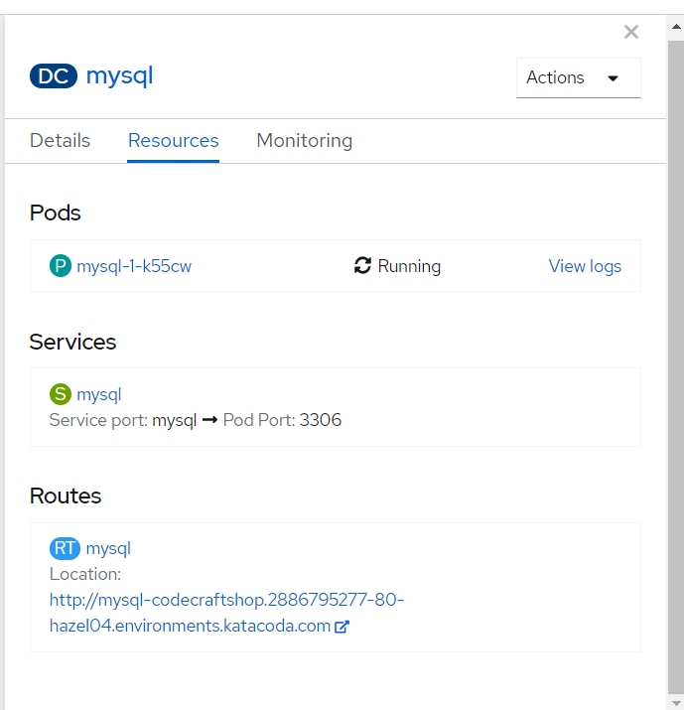

You can describe service using below mentioned command:  
oc describe svc/mysql -n <namespace>

